

Inductance and Capacitance Meter

Group Composition

Migara Akalanka Fernando (17029527)

Dilshara Amarathunge (17029529)

Dinith Sriyan Jayasinghe (17029525)

Group Design and Integration Project

UFMFV8-15-3

21st August 2019

# Acknowledgement

First and foremost, we would like to express our heartfelt gratitude to our module leader, Ms. Lihini Wijesinghe for the constant supervision and assistance given throughout this project. We were privileged to have her help all along the completion of this project.

We are extremely thankful to our program leader Ms. Maithrayei Sivalingam, and laboratory assistant Mr. Naushad and all other lecturers at Northshore College for helping us to making this project a success.

We would not forget to remember our batch mates and seniors who gave us their encouragement and help until the completion.

# Abstract

This report is about developing an Inductance and capacitance meter (LC Meter), which is used to take measurements of any unknown inductance or capacitance component. Due to the high cost and less availability of LC meters compared to the other measuring equipment, this is very useful to fulfill electrical and electronic measuring requirements at a low cost. A very simple theory is used the main principle of this module’s basic circuit.

The module contains a detecting part for the unknown component, which contains a known inductor and a capacitor that generates a resonant frequency along with the unknown component acting as an LC tank circuit in resonance. The results are calculated based on this frequency generated by the known and unknown component combination. Then the frequency is processed and given as the input to the Microcontroller and calculates results to display in the LCD screen.

Starting from the unknown inductor/ capacitor detection, frequency generation and frequency processing until result calculation using the microcontroller, all the methodologies considered, module design, implementation, software testing, simulation, hardware testing and simulation are described in this report.

The module was developed using available standard electronic components in order to get the accurate results since the measurements have to be correct as best as possible.

# Contents

Acknowledgement 2

Abstract 3

Contents 4

Table of Figures 6

1. Introduction 7

1.1 Background 8

1.2 Problem Identification 9

1.3 Aim and Objectives 10

1.4 Project Scope and Limitations 11

2. Literature Review 12

2.1 Voltage Detection and frequency generation 12

2.2 LC resonance and AC to DC signal conversion 13

2.3 Data Processing 13

2.3.1 PIC Microcontroller 13

2.4 Output of the calculated Result using display devices 14

3. Methodology 15

3.1 Overview 15

3.2 Combination 1 15

3.3 Combination 2 16

3.4 Combination 3 17

3.5 Optimum Method 18

4. Design and Implementation 19

4.1 Hardware Design and Implementation 19

4.1.1 Power Supply Unit 19

4.1.2 Unknown Component Input 19

4.1.3 Differential Comparator Circuit 20

4.1.4 PIC microcontroller and LCD display 20

4.1.5 Final PCB Design 21

4.1 Software Implementation 23

4.1.1 Pulse Counting for frequency Calculation 23

4.1.2 Final Result Calculation 24

5. Test and Simulation 26

5.1 Differential Comparator Unit 26

5.2 Microcontroller Programming and results 27

5.2.1 MikroC Pro for PIC software and mikro C language 27

5.2.2 PICkit 3 uploading kit 27

5.2.3 Frequency Calculation 28

5.2.4 Capacitance / Inductance mode switching 29

5.3 Final hardware testing and Results 29

5.3.1 Frequency Measurements 29

5.3.2 Capacitance Measurements 30

6. Conclusion and Further Development 31

6.1 Conclusion 31

6.2 Further Development 31

7. References 32

8. Appendices 34

8.1 Appendix A – Work Plan 34

8.1 Appendix B – Source Code 34

# Table of Figures

Figure 1 - An Inductor 8

Figure 2 - A capacitor 8

Figure 3 - Basic LC tank circuit and resonant frequency equation 9

Figure 4 - Design combination No 1 15

Figure 5 - Design Combination No 2 16

Figure 6 - Design Combination No 3 17

Figure 7 - Power supply unit with the voltage regulator 19

Figure 8 - Switching between the inductance and capacitance 19

Figure 9 - unknown component input switch and differential comparator unit 20

Figure 10 - simulation results for the connection between PIC microcontroller and LC display 21

Figure 11 - PCB design in proteus 21

Figure 12 - Final PCB design 22

Figure 13 - Final Proteus Simulation Diagram 22

Figure 14 - Timer1 block diagram 23

Figure 15 - Code part for pulse counting 24

Figure 16 - Unknown component connection to the resonant circuit 24

Figure 17 - Inductance and capacitance calculation 25

Figure 18 - Code for capacitance and inductance calculation and switching between inductance and capacitance 25

Figure 19 - Input and Output signals from the bread board implementation 26

Figure 20 - LM311 differential comparator Implementation 26

Figure 21 - MikroC Pro for PIC software 27

Figure 22 - PICkit 3 pin diagram 28

Figure 23 - frequency calculation using an external pulse generator 28

Figure 24 - Switching between the inductance and capacitance 29

Figure 25 - Input and output waveforms from the circuit 29

Figure 26 - Capacitance measurement 30

# Introduction

## Background

When it comes to any calculation or operation in an electrical circuit, inductance and capacitance are two main electrical components that comes to the show. The magnetic induction rate of an inductor is defined as Inductance and the electrical capacity that a capacitor can hold, is called as the capacitance value of that particular capacitor.



Figure 1 - An Inductor

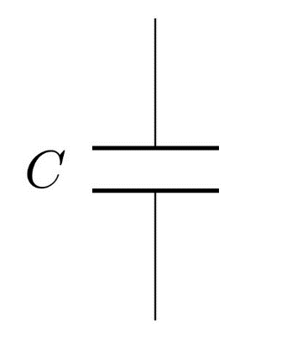

Figure 2 - A capacitor

Inductance and capacitance are difficult to measure unless the components are labeled with the value. This project is implemented in order to surpass that obstacle. To create this LC meter, a PIC microcontroller will be used as a mini computer since the calculations are done according to the resonant frequency equation, which is given below.

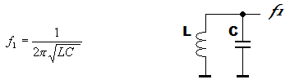

Figure 3 - Basic LC tank circuit and resonant frequency equation

In the circuit, the tank circuit will generate the resonant frequency and a comparator processes it. Then the PIC microcontroller will receive them and calculate the desired inductance or capacitance value, using the other known parameter and the measured frequency, applying to this equation. Then the display device outputs it.

## Problem Identification

When it comes to the problem identification, there are few problems with regarding the determination of inductor or a capacitor.

* Difficult to determine the value at first sight

The inductance or the capacitance of most of the components are not directly labelled in them. There are special naming methods for them that people with no experience in electronics may not understand.

* The real value can be different from the labelled value

The labelled value can be deviated from the real value with effect of the time and even if we know the value of components, when it comes to practical scenarios, theoretical based calculations can be inaccurate.

* Measuring values for the components which are not labelled

There might be hand-made inductors or capacitors which are not standard or available in the market. Therefore there must be a way to calculate their values in order to use them as substitutions for applications.

## Aim and Objectives

**AIM**

Our aim is to design and implement an accurate, cost-effective and less tolerant inductance and capacitance measuring equipment.

**OBJECTIVES**

* Studying the PIC microcontroller system
* Studying the properties of inductors and capacitors in electrical circuits
* Studying about the frequency generating module and frequency generation
* Design the Schematic diagram of the circuit using Proteus software and simulation
* Design the PCB using Proteus software
* Making the circuit and soldering
* Testing and observing the results of the project
* Fine tune the module for better value approximations

## Project Scope and Limitations

The project workload will be in a scope of designing, testing and implementing domains. Software design and Hardware design, design Simulating and observing the results prior to creating the circuit and implementing the hardware will be the working process of the project.

The deliverables will bethe source code, Completed circuit, the Test results and simulation reports and the Final report.

**The limitations and constraints of the module can be listed as below.**

* Can’t achieve 100% accuracy
* Unexpected hardware errors can be occurred due to electronic components malfunctioning
* No automatic switching between the measurable parameters
* Measuring range is limited

All the codes of the course will be done using mikro C language.

# Literature Review

## Voltage Detection and frequency generation

According to (Mahar E. Rizkalla, 1992)there are two main methods to create a corresponding output which can be detected as an acceptable input for the micro controller, in order to proceed the inductance, capacitance calculations. This output has to be proportional to the detected voltage difference level of the component two terminals which has an unknown inductance or capacitance. In detail, there are two different approaches can be followed to perform for dynamic measurements.

The first approach is, using the time response of the circuit created by a frequency generator, to determine the unknown electrical component. There are some problems encountered with this method include voltage comparators, and switching the circuit element which restrict the procedure to off board texting, while it allows L and C to be measured in the circuit dynamically for a wide range of frequencies.

The method of LC oscillator is used in order to measure the circuit values, directly. The unknown electronic component can be determined by detecting the frequency of the LC oscillator that results from a known standard circuit element with an unknown one which can be simply calculated.

According to(M.E. Rizkalla, 1992), in the resonance frequency method, the circuit element being measured is inserted into one of the two RLC oscillators for measuring inductance or capacitance.

How the method of using an LC oscillator is better since the tank circuit hasn’t to be fed with an external oscillation or pulse in order to get the required oscillation in order to input to the comparator and get the digital output.

## LC resonance and AC to DC signal conversion

An LC tank circuit with a differential comparator can be used to create the corresponding resonant frequency of the LC tank. This is called an LC oscillator circuit. Since the microcontroller is capable of calculating the frequency of a digital signal, the sinusoidal resonating frequency wave has to be converted into a digital signal to give as the input to the microprocessor.

Otherwise an input signal or a pulse can be taken as an output from the microcontroller and feedback it into the LC circuit again to make the LC circuit oscillate. Then the circuit starts to electronically ring like a bell, in a frequency which totally depends on the values of the corresponding capacitor.

## Data Processing

### PIC Microcontroller

According to (NGURE, 2009) a microcontroller is a small computer or an advanced calculating device, they are low in cost and self-sufficient. But a microcontroller is designed not only to be a computing device but an intelligent for dedicated systems.

PIC (peripheral interface controller) is the mostly used type of microcontrollers since and its functionally is advanced to do considerably advanced tasks and easy to code.

A microcontroller usually consists of a central processing unit, internal clock, timers, counters, input output ports, memory for program data.

In this scenario, the PIC microcontroller has to be used to calculate the given the frequency value of the given digital signal and then calculate the inductance or capacitance value according to the resonance.

To calculate this frequency, according to (Mahar E. Rizkalla, 1992), a frequency counter has to be implemented inside the micro controller in order to count the number of pulses per second is given as the input. Then it should calculate the desired capacitance or inductance utilizing the zero-error voltage at resonance.

The ports of the microcontroller have to be configured first. This means the pins of a particular port of the micro controller have to be initialized as inputs or outputs according to their operation throughout the process. Therefore, the pin which gets the timer input signal has to be configured as an input. If there is only a limited number of pins work for the process, as inputs or outputs, the code should be written only for them. The pins for the crystal oscillator of the microcontroller and the power input have not to be initialized.

There are several types of microcontrollers that can be classified by some factors. They are, Internal bus width of the microcontroller (8-bit, 16-bit and 32-bit), type of instruction set (CISC, RISC), memory architecture and etc.

## Output of the calculated Result using display devices

To output the results from a microcontroller, there should be a display device. There are several types of display devices in electronics. Here in this project a 16 x 2 LCD display is used. LCDs are alphanumeric displays which are frequently used in microcontroller applications. They are mainly two types as series and parallel displays. When it comes to interfacing the LCD to microcontroller, usually there are more than one line and four lines are usually used to transfer the data from the microcontroller circuitry. There are special LCD libraries available in programming languages so that the operation of the display makes much easier. In 16x2 LCD, there is one pin to power up the display and one can be used to control the contrast of the display. Its operating voltage is 4.7 V to 5.3 V. This is low cost, highly available and is capable of displaying large number of characters.

# Methodology

## Overview

Since we use our LC meter (Inductance and Capacitance meter) to measure reactive electrical components of a circuit. The following are some possible methods to implement this circuit.

1. Combination 1 - LC Meter using NE555 and PIC 16F628A
2. Combination 2 - LC Meter using LM311 and PIC 16F877A
3. Combination 3 - LC Meter using LM399 and ATmega328P

## Combination 1

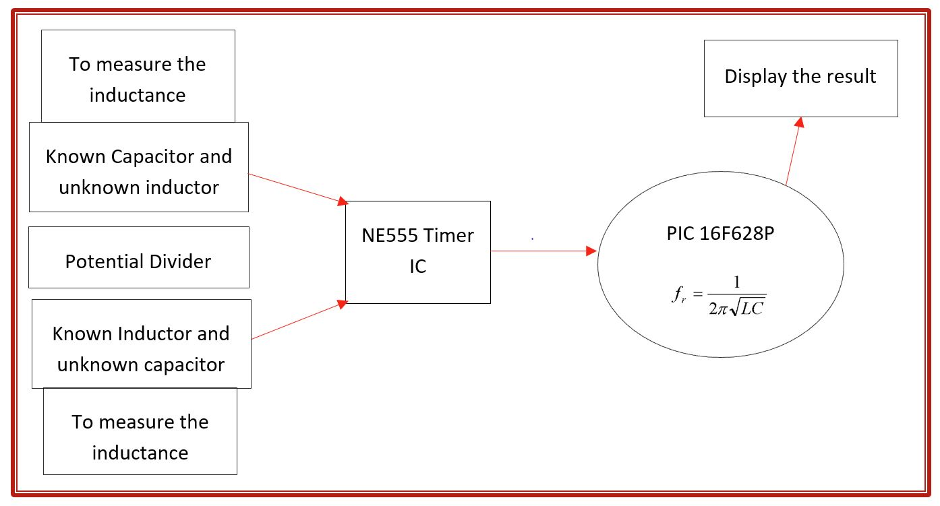

Figure 4 - Design combination No 1

In this method, a potential divider is arranged using a capacitor and inductor along with a resistor in order to get an output voltage across the capacitor and inductor from giving an AC voltage as input.

Then this voltage is fed as an input to the control pin of the 555 timer IC, making an output signal which is proportional to the control voltage. Then this signal (in the form of pulses) is fed to the microcontroller to calculate the Inductor and capacitor value according to the frequency.

## Combination 2

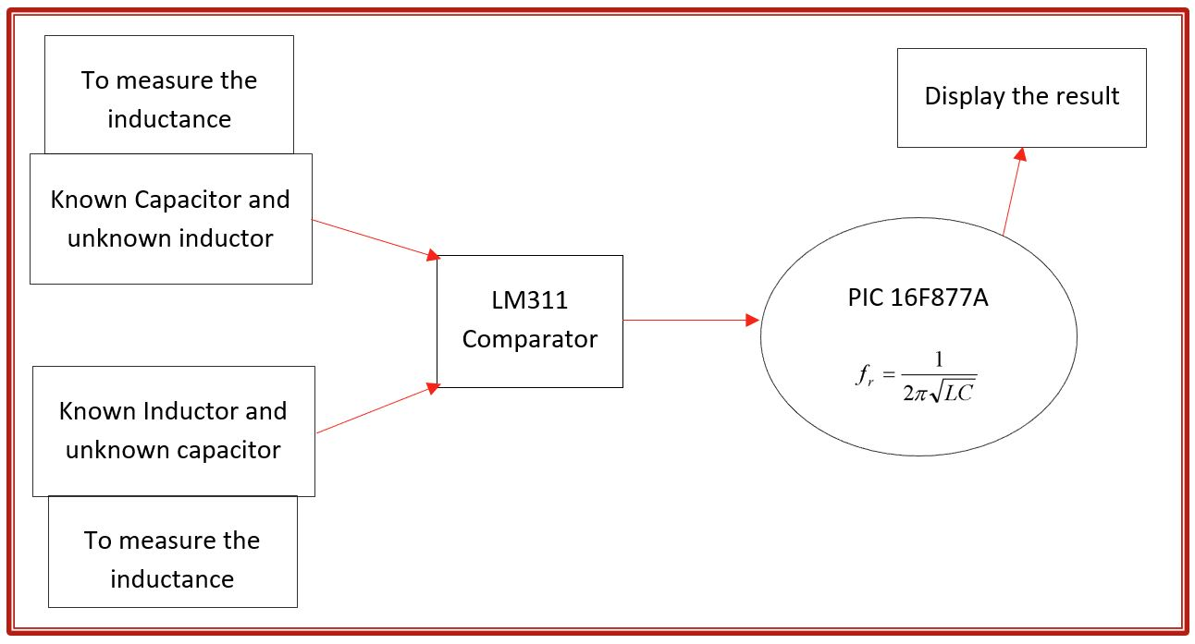

Figure 5 - Design Combination No 2

In this combination, LM311 is used in order to execute the LC tank resonance with giving power only to the comparator. It automatically makes the LC circuit resonant and receive the sinusoidal wave and then convert it to a digital clock pulse of the same frequency as the resonant sinusoidal wave signal. Therefore, using LM311 is easier in the sense it generates sinusoidal wave and convert it into a DC clock to input to the pin as well.

The reason to use PIC16F877A is none other but having a better performance having the timer1 module in order to count the number of pulses. The frequency level that can be counted using PIC16F877A is larger and even an enhanced coding functionality can be added since it has a comparably larger program memory.

## Combination 3

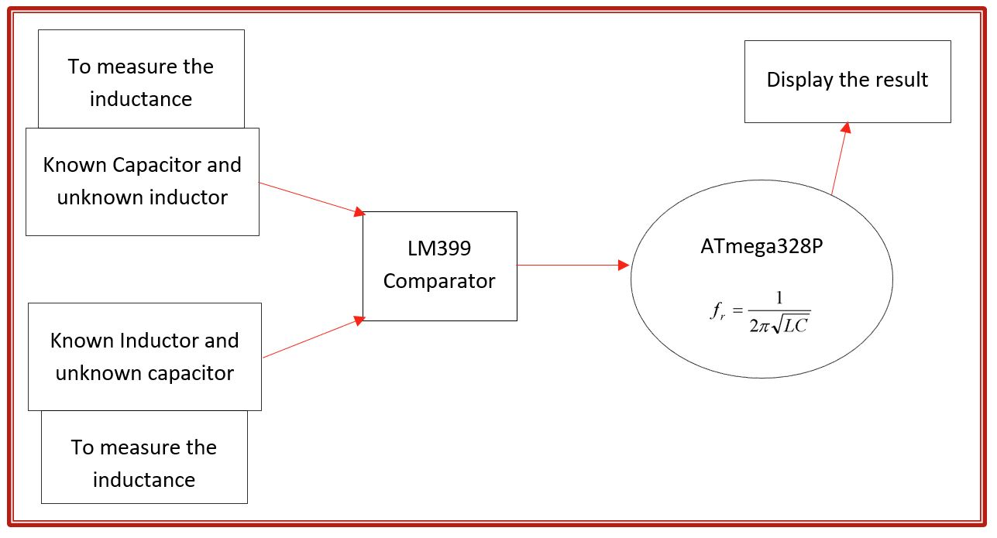

Figure 6 - Design Combination No 3

When it comes to Atmega328p controller, it can sample signals at 9600 Hz or 0.1 ms, which can be considered as somewhat fast but not in required level. It can be used to turn real world signals into basic digital signals. Now micro controllers are terrible at analyzing analog signals. The ATMEGA328 ADC is capable of sampling analog signals at 9600 Hz or .1ms, which is fast but nowhere near what this project requires. Let’s go ahead and use a chip specially designed for turning real world signals into basic digital signals: The LM339 comparator which switches faster than a normal LM741 op amp, but there will be a schematic for the LM741 too.

As soon as the voltage on the LC circuit becomes positive, the LM339 will be floating, which can be pulled high with a pull up resistor. When the voltage on the LC circuit becomes negative, the LM339 will pull its output to ground. I’ve noticed that the LM339 has a high capacitance on its output, which is why I used a low resistance pull up.

So, what we will do is applying a pulse signal to the LC circuit. In this case it will be 5 volts from the Arduino. We charge the circuit for some time. Then we change the voltage from 5 volts directly to 0. That pulse will make the circuit to resonate creating a cushioned sinusoidal signal osculating at the resonant frequency. What we need to do is to measure that frequency and later using the formulas obtain the inductance value. We will use the Arduino to measure the frequency and calculate the value.

## Optimum Method

Since the resonance and digitized output both can be achieved by a single configuration, our optimum design would be no 2. Therefore, the main components of our module will be LM311 and PIC16F877A.

* LM311 – To make the LC tank resonant and give the resonant frequency output in the form of a digital clock.
* PIC16F877A – To input the clock pulse and calculate the unknown component value corresponds to the frequency.

# Design and Implementation

## Hardware Design and Implementation

### Power Supply Unit

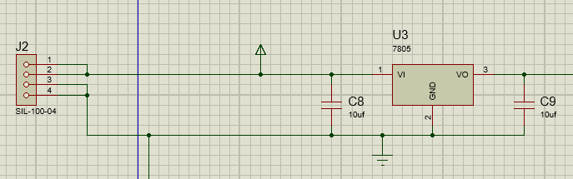

Figure 7 - Power supply unit with the voltage regulator

Power is given to the circuit through a voltage regulator keeping the output voltage from the power supply unit constant to 5V. A 9V battery will be connected to give the power to the circuit.

### Unknown Component Input

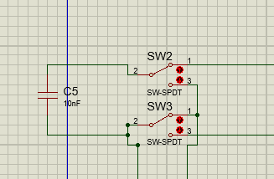

Figure 8 - Switching between the inductance and capacitance

The switch between the capacitance and inductance makes the output the PIC to calculate the required value when a capacitor or inductor connected. When switch is opened to the upper side, it calculates the value of a capacity connected to the tank circuit in parallel.

When the switch is down, an inductor is connected to the tank circuit in series with the reference inductor and gives a power input to the D3 pin in PIC micro controller so that in the code it reads if the value of D3 pin is high, It will calculate the inductance value connected in series with the inductor of the tank circuit.

### Differential Comparator Circuit

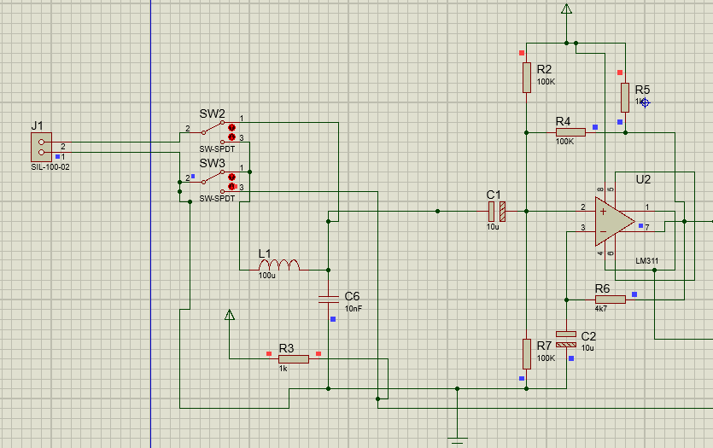

Figure 9 - unknown component input switch and differential comparator unit

The LM311 differential comparator unit makes the tank circuit resonant and takes its sinusoidal input to give a digital form of the frequency signal as its output to the PIC microcontroller.

### PIC microcontroller and LCD display

The PIC microcontroller and LCD display is connected according to the standard pin configuration. The following simulation result gives the resonant frequency value when an inductor or a capacitor is not connected. So, we got this value as the reference frequency and calculate the unknown reactance value using it and the reference inductance and reference capacitance.

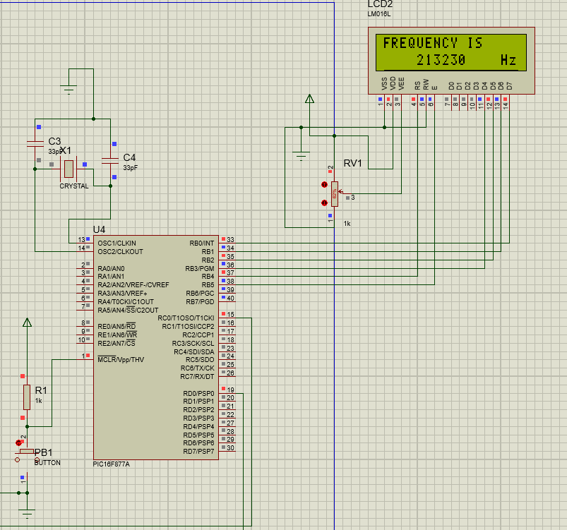

Figure 10 - simulation results for the connection between PIC microcontroller and LC display

### Final PCB Design

Final PCB design is done using Proteus software. The following images shows the schematic version and PCB pdf version.

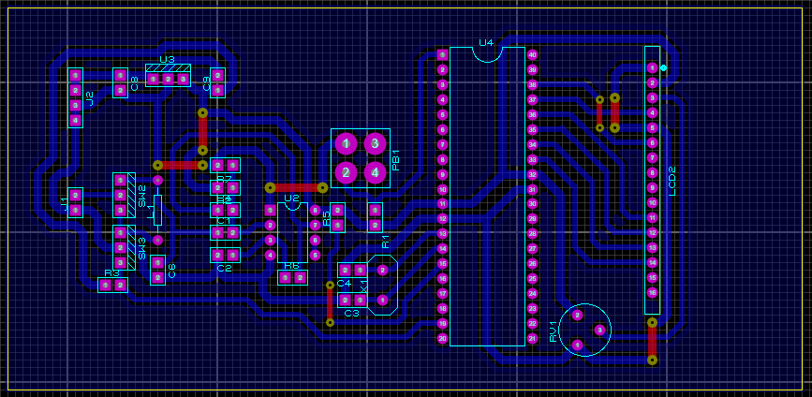

Figure 11 - PCB design in proteus

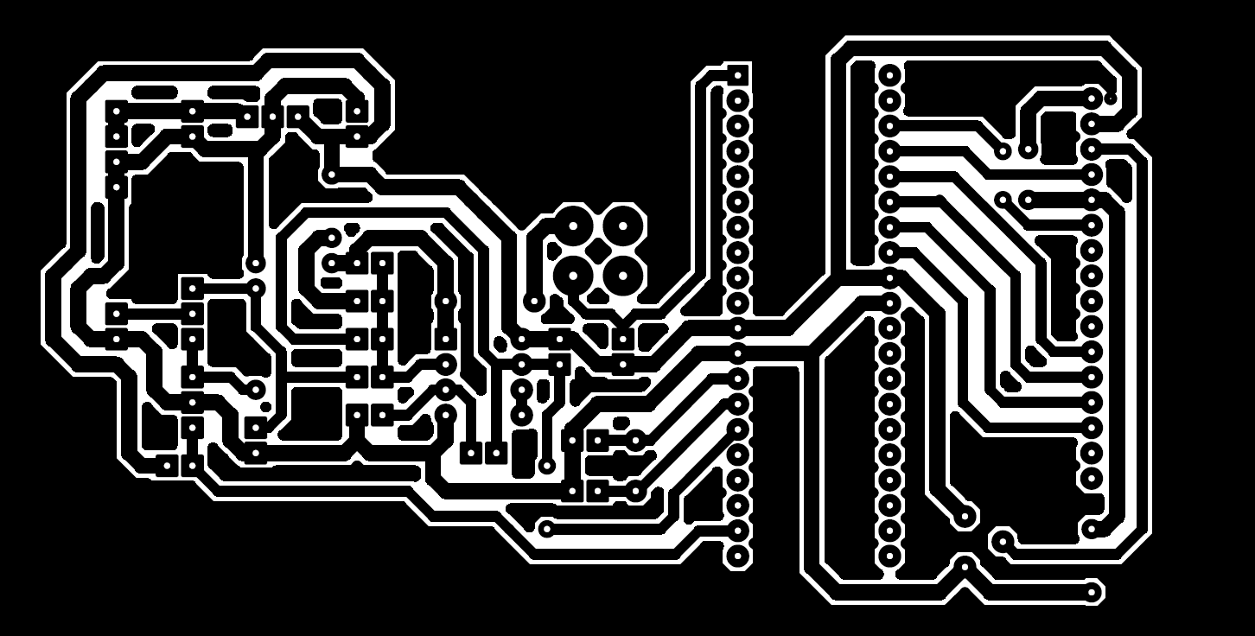

Figure 12 - Final PCB design

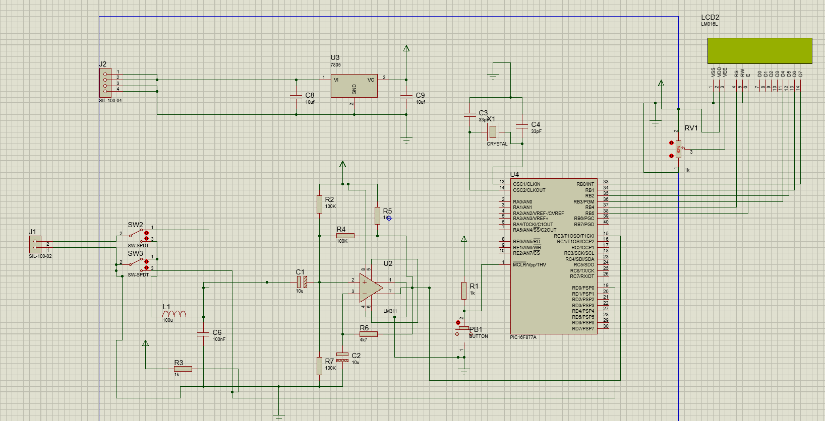

Figure 13 - Final Proteus Simulation Diagram

## Software Implementation

### Pulse Counting for frequency Calculation

To count the pulses given to the PIC micro controller as the input from the resonant circuit, we have used to T1CK1 pin (15) which uses the TIMER1 to calculate the number of pulses per second.

* **TICON Register and Timer1 module**

The timer TMR1 module is a 16-bit timer/counter. It has following features.

* 16-bit timer/counter with two TMR1H/TMR1L 8-Bit registers
* Readable and writable
* Prescaler upto 1:8
* Select internal or external clock
* Interrupt on overflow from FFFFh to 00h
* Selecting edge for external clock

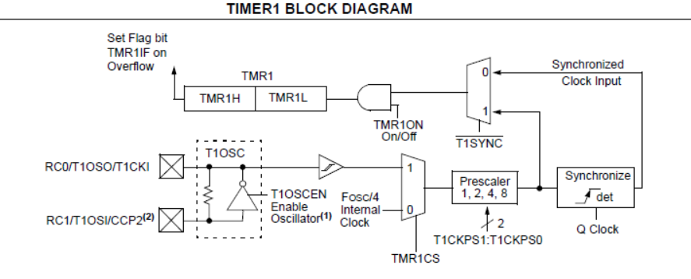

Figure 14 - Timer1 block diagram

* **Pulse counting and frequency calculation (code):**

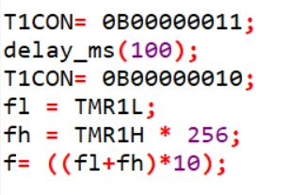

Figure 15 - Code part for pulse counting

According to this code, it gives the final value of the frequency. TMR1L and TMR1H stores the values of the pulse count. Then we add TMR1L value and TMR1H overflowed value.

### Final Result Calculation

* **LC circuit**

When the mode is switched the unknown capacitance connected parallel to the LC tank circuit and unknown inductance value is connected in parallel with the reference inductor.

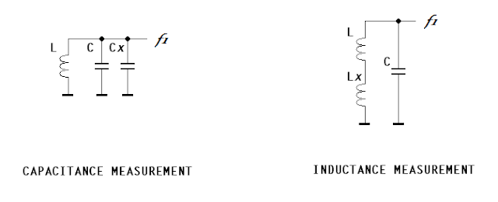

Figure 16 - Unknown component connection to the resonant circuit

* **Calculation**

The frequency is calculated using the proportionality of the root of the LC multiplication with the resonant frequency. The new frequency and the old frequency is compared and the final calculation is done by dividing the new and old proportional equations.

$$f∝\frac{1}{\sqrt{LC}}$$

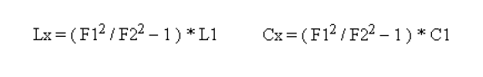

Figure 17 - Inductance and capacitance calculation

* **Code part**

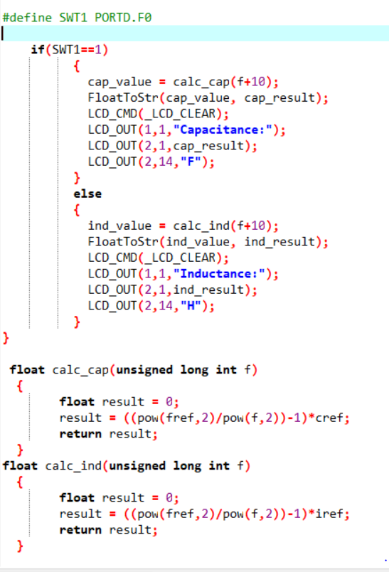

Figure 18 - Code for capacitance and inductance calculation and switching between inductance and capacitance

# Test and Simulation

## Differential Comparator Unit

The LM311 differential comparator unit oscillates the LC tank circuit and creates a sinusoidal wave and then it converts it into a clock pulse. The following bread board implementation test results shows the input and output to LM 311 in yellow and blue colours respectively.

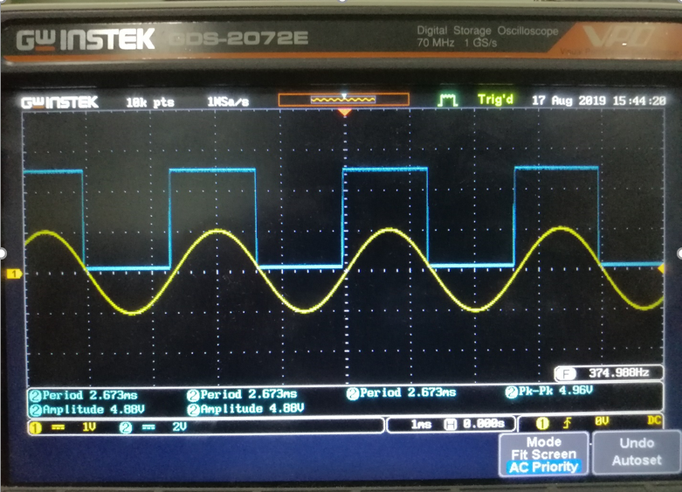

Figure 19 - Input and Output signals from the bread board implementation

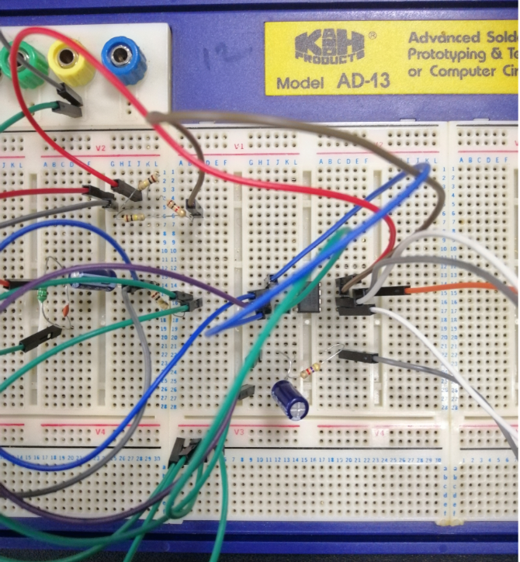

Figure 20 - LM311 differential comparator Implementation

## Microcontroller Programming and results

### MikroC Pro for PIC software and mikro C language

MikroC Pro for PIC was the software we used for programming the PIC microcontroller. It is very easy to use and it directly creates a hex file which is directly uploadable to the microcontroller once we compile the written code.



Figure 21 - MikroC Pro for PIC software

### PICkit 3 uploading kit

PICkit 3 is the gadget that we used to upload the hex file created by MikroC Pro for PIC software to the PIC microcontroller. It has 5 pins to connect to the pic and upload the program to it. It has a feature that it can change the voltage that has to apply when the program is uploading to the PIC micro controller.

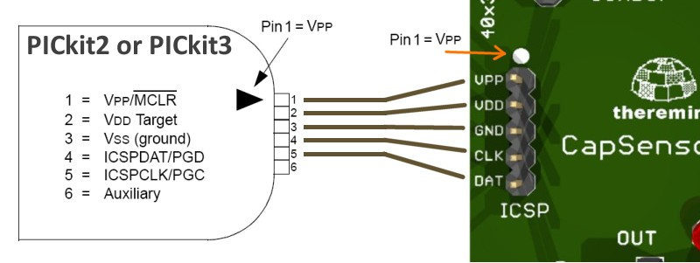

Figure 22 - PICkit 3 pin diagram

### Frequency Calculation

The frequency calculation is tested first by using an external DC pulse from the signal generator.

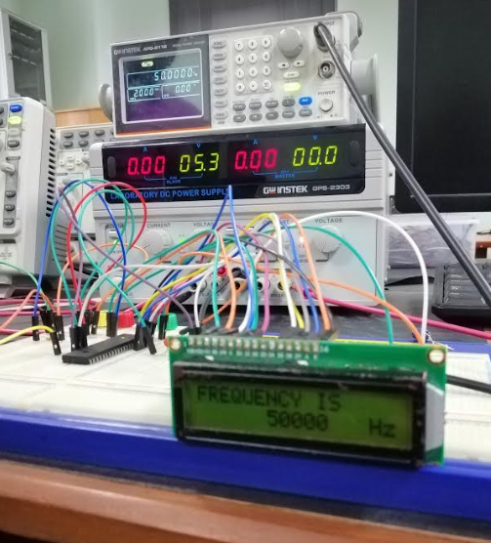

Figure 23 - frequency calculation using an external pulse generator

### Capacitance / Inductance mode switching



Figure 24 - Switching between the inductance and capacitance

The switch between the inductance and capacitance turns on a power when the inductance is connected then it reads the power input as high to the PIC and changes the calculation according to the input.

## Final hardware testing and Results

### Frequency Measurements

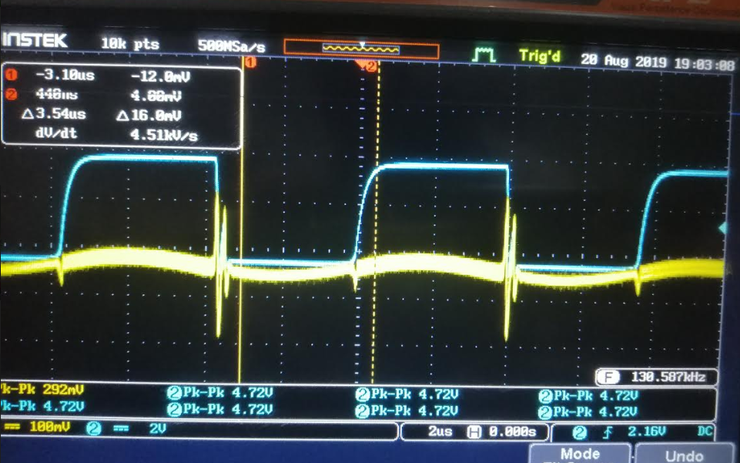

Figure 25 - Input and output waveforms from the circuit

### Capacitance Measurements

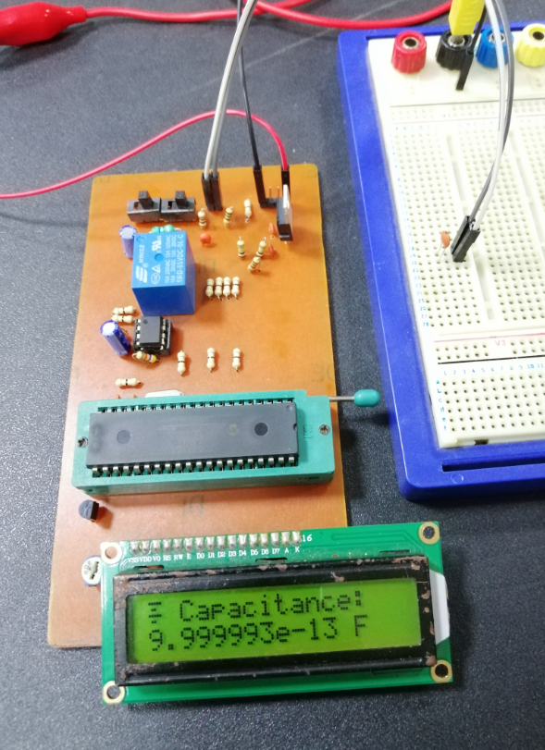

Figure 26 - Capacitance measurement

Frequency, signals and reactance values are tested using the circuit. But the values were not 100% percent accurate. But the values gives a close approximation with the given value.

# Conclusion and Further Development

## Conclusion

Since inductance and capacitance are most important electrical components of a system along with the resistance, determining the values of them is also important. Since the less availability and high cost of LC meters, the development of a new LC is important. So, using LM311 differential comparator circuit configuration and PIC16F877A microcontroller, the new simple inductance and capacitance meter is developed and it is capable of measuring inductances from 10uH up to 100mH and capacitances from 10nF up to 100uF. Therefore, the range of the LC meter is in a considerable amount and the inductance and capacitance modes can be switched. Apart from them, the circuit is a small compact one, giving the real meaning of a measuring meter. Since the power requirement is small and the response time is also small, this module can be identified as an energy efficient and time saving measuring instrument.

## Further Development

The circuit module can be further developed to measure and output the frequency of an unknown external source, making it an inductance capacitance and frequency meter.

We can develop the module into a circuit so that it measures the values in a wide range changing the configuration if the circuit.

We can include previous values logging and keeping in memory functionality for the circuit as well. It will help the user to memorize previously measured values.

# References

A. Pokatilov, A. S. T. K. O. M., 2010. *VERIFICATION OF PERFORMANCE OF COMMERCIAL LCR METERS.* Daejeon, Korea, Conference on Precision Electromagnetic Measurements.

Arjav Harjai, A. B., 2016. *TUDY OF MAXIMUM POWER POINT,* Orissa: Department of Electrical Engineering - National Institute of Technology.

best-microcontroller-projects, 2016. *A PIC frequency counter operating up to about 50 MHz..* [Online]   
Available at: https://www.best-microcontroller-projects.com/pic-frequency-counter.html  
[Accessed July 2019].

Bindu, B., 2016. *Digital frequency counter with an LCD desplay using micrco controller.* [Online]   
Available at: https://www.studentcompanion.co.za/digital-frequency-counter-with-an-lcd-display-using-pic-microcontroller-mikroc/  
[Accessed August 2019].

Bryan Waltrip, S. A.-Z. ,. A. K., 2005. *Inductance Measurement Using an LCR Meter.* Ottawa, Canada, Instrumentation and Measurement Technology Conference.

Dhananjay Choudhary, A. R. S., 2014. DC-DC Buck-Converter for MPPT of PV System. *International Journal of Emerging Technology and Advanced Engineering,* p. 814.

DIY, E. -., 2016. *Very Accurate LC Meter based on PIC16F628A.* [Online]   
Available at: http://electronics-diy.com/lc_meter.php  
[Accessed June 2019].

Dr. S. V. Viraktamath, K. K. B. K., 2017. *Digital LCR Meter using Arduino.* Dharwad, Karnataka, India, IEEE.

Hart, D. W., 2010. *POWER ELECTRONICS.* Valparaiso: McGrawHill.

Kuhne, H., 1992. *Inductance-Capacitance Meter,* s.l.: Front cover project.

Lab, M., 2014. *Digital frequency meter using pic microcontroller.* [Online]   
Available at: https://microcontrollerslab.com/digital-frequency-meter-with-lcd-display/  
[Accessed August 2019].

Linu Ann Thomas, M. A. J. M. J., 2016. MPPT TECHNIQUE USING SEPIC CONVERTER TO TRACK MAXIMUM POWER POINT FOR PV PANEL. *International Journal of Scientific & Engineering Research, Volume 7,* pp. 675-682.

Mahar E. Rizkalla, H. G. G. M. T. K., 1992. *A microprocessor based dynamic Inductance/Capacitance meter,* Indianapolis: Perdue university.

M, P., 2013. *Understanding an LC meter - Forum Thread.* [Online]   
Available at: https://forum.allaboutcircuits.com/threads/understanding-an-lc-meter.86766/  
[Accessed July 2019].

NGURE, M. E., 2009. *MICROPROCESSOR CONTROLLED DIGITAL CLOCK,* Nairobi,Kenya: university of Nairobi.

Nguyen, D., 2011. *Microcontroller Based Inductance Meter,* San Luis Obispo: ELECTRICAL ENGINEERING DEPARTMENT, California Polytechnic State University.

Sachin Satheesh1, P. T. U. V., 2016. MICROCONTROLLER BASED LCR METER. *International Research Journal of Engineering and Technology (IRJET),* 03(06), pp. 1790-1792.

Sooraj_Shenoy, 2013. *FLC METER USING 16F877A (DE_METAL_AMIGO).* [Online]   
Available at: http://soorajshenoys.blogspot.com/2013/10/flc-meter-demetalamigo.html  
[Accessed July 2019].

W.S. Mada Sanjaya, A. R. D. A. M. M. S. F. D., 2018. *Portable Electronic Capacitance Meter using Resonance Method for Lard Capacitance.* Yogyakarta, Indonesia, 3rd International Conference on Information Technology, Information Systems and Electrical Engineering.

Wikipedia, n.d. *LC circuit.* [Online]   
Available at: https://en.wikipedia.org/wiki/LC_circuit  
[Accessed July 2019].

# Appendices

## Appendix A – Work Plan

## Appendix B – Source Code

#define SWT1 PORTD.F0

sbit LCD_RS at RB4_bit;

sbit LCD_EN at RB5_bit;

sbit LCD_D7 at RB0_bit;

sbit LCD_D6 at RB1_bit;

sbit LCD_D5 at RB2_bit;

sbit LCD_D4 at RB3_bit;

sbit LCD_RS_Direction at TRISB4_bit;

sbit LCD_EN_Direction at TRISB5_bit;

sbit LCD_D7_Direction at TRISB0_bit;

sbit LCD_D6_Direction at TRISB1_bit;

sbit LCD_D5_Direction at TRISB2_bit;

sbit LCD_D4_Direction at TRISB3_bit;

float iref = 0.0001;

float cref = 0.00000001;

float fref = 214000;

float calc_cap(unsigned long int f);

float calc_ind(unsigned long int f);

char cap_result[11],ind_result[11];

unsigned long cap_value,ind_value;

void main() {

unsigned long fl=0,fh=0;

unsigned long f=0;

float cap_value,ind_value;

char txt[5],txt1[5],*res;

lcd_init();

lcd_cmd(_LCD_CLEAR);

lcd_cmd(_LCD_CURSOR_OFF);

lcd_cmd(_LCD_CLEAR);

TRISC= 0b11111111;

PORTC= 0b00000000;

TRISB=0;

TRISD = 0b11111111;

PORTD = 0b00000000;

TMR1L=0;

TMR1H=0;

lcd_out(1,1,"WORKING..");

delay_ms(100);

lcd_out(1,1,"WORKING….");

delay_ms(1000);

T1CON= 0B00000011;

delay_ms(100);

T1CON= 0B00000010;

fl = TMR1L;

fh = TMR1H * 256;

f= ((fl+fh)*10);

if(SWT1==1)

{

cap_value = calc_cap(f+10);

FloatToStr(cap_value, cap_result);

LCD_CMD(_LCD_CLEAR);

LCD_OUT(1,1,"Capacitance:");

LCD_OUT(2,1,cap_result);

LCD_OUT(2,14,"F");

}

else

{

ind_value = calc_ind(f+10);

FloatToStr(ind_value, ind_result);

LCD_CMD(_LCD_CLEAR);

LCD_OUT(1,1,"Inductance:");

LCD_OUT(2,1,ind_result);

LCD_OUT(2,14,"H");

}

}

float calc_cap(unsigned long int f)

{

float result = 0;

result = ((pow(fref,2)/pow(f,2))-1)*cref;

return result;

}

float calc_ind(unsigned long int f)

{

float result = 0;

result = ((pow(fref,2)/pow(f,2))-1)*iref;

return result;

}